Name Goes Here
Soc 152C

1. Placement: Pregnancy→Pregnancy Overview
Link: http://www.soc.ucsb.edu/sexinfo/?article=i525

Replace the second picture with the first.
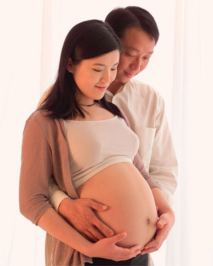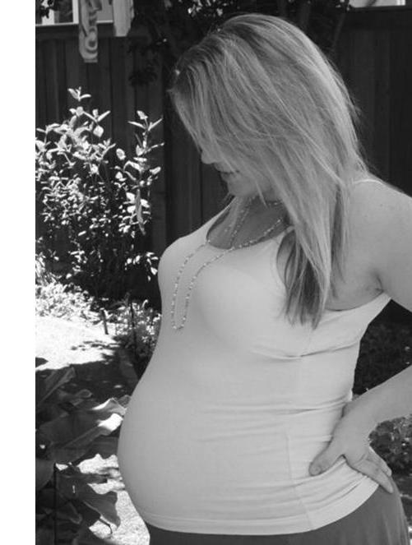

2. Placement: Love & Relationships→ Surviving a Break-Up→ Loneliness
Link: http://www.soc.ucsb.edu/sexinfo/?article=QC6c

Picture Link: http://www.asdfing.com/wp-content/uploads/2007/12/how_to_survive_a_breakup1.jpg

